**Experiment 1.2**

**Student Name: Rahul Kumar UID: 20BCS7081**

**Branch: CSE Section/Group: 716/B**

**Semester: 6th Date of Performance: 27 Feb 2023**

**Subject Name: CC lab**

**AIM -**

**To demonstrate the concept of String Matching algorithms**

**Objective –**

To learn about string and using to find the match

**Requirement -**

Vscode, personal computer, 9th generation , etc.

**Question 1-**

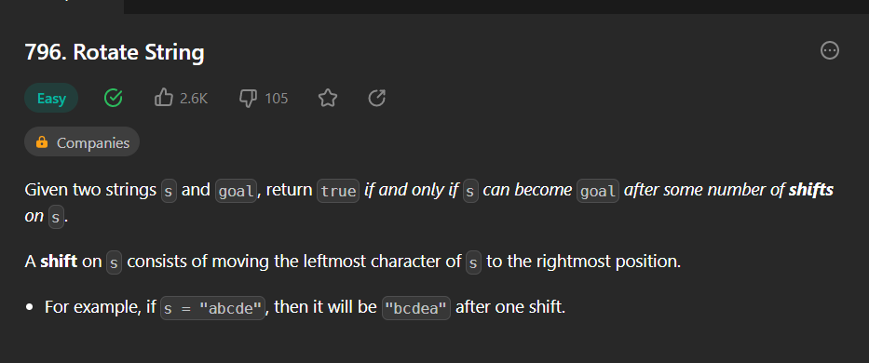

**Answer –**

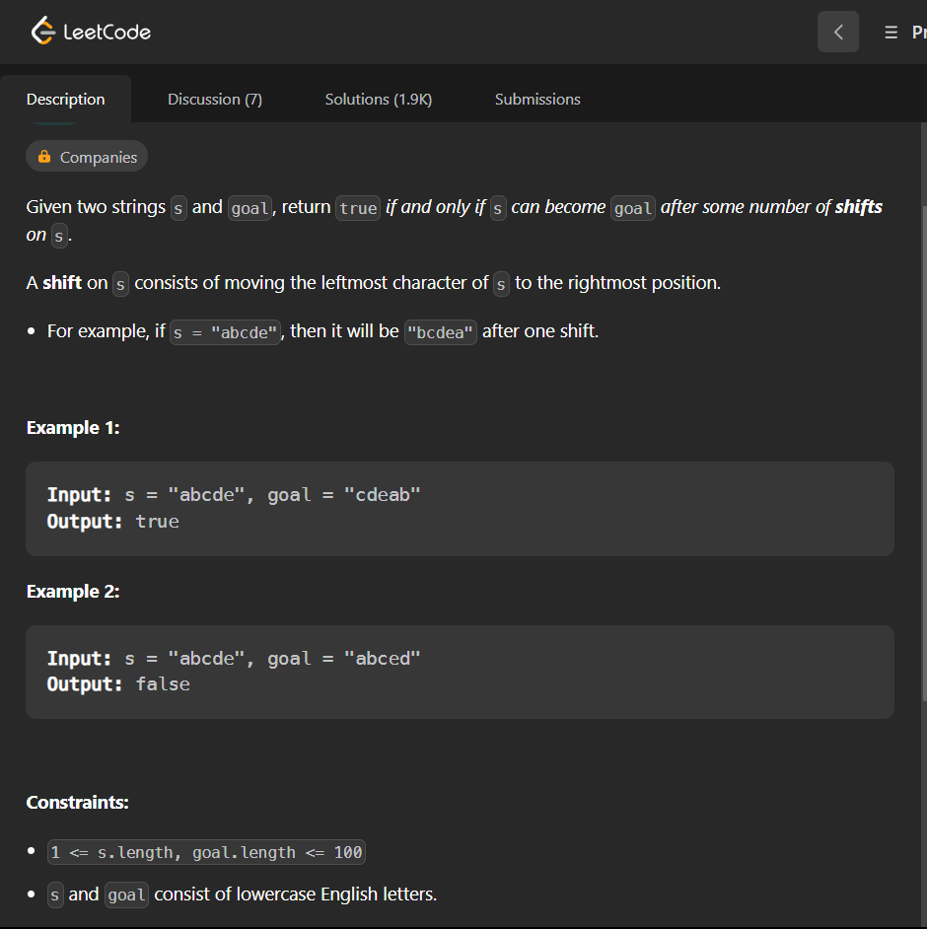

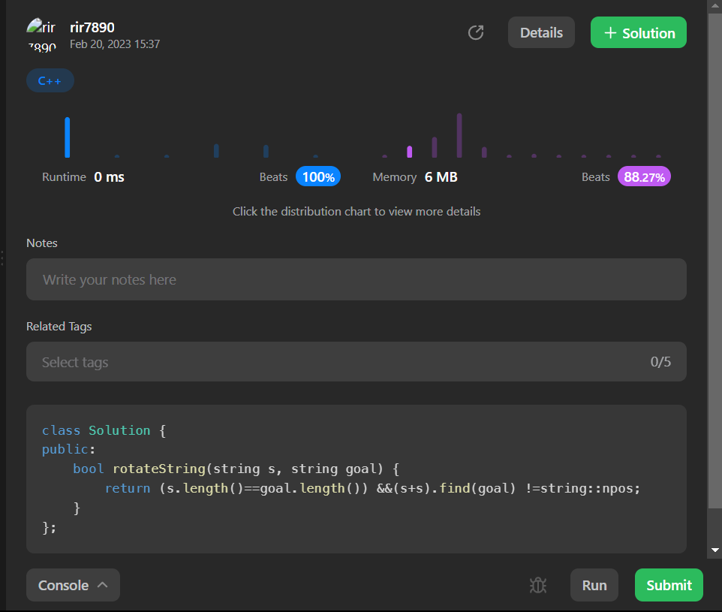

**Question 2-**

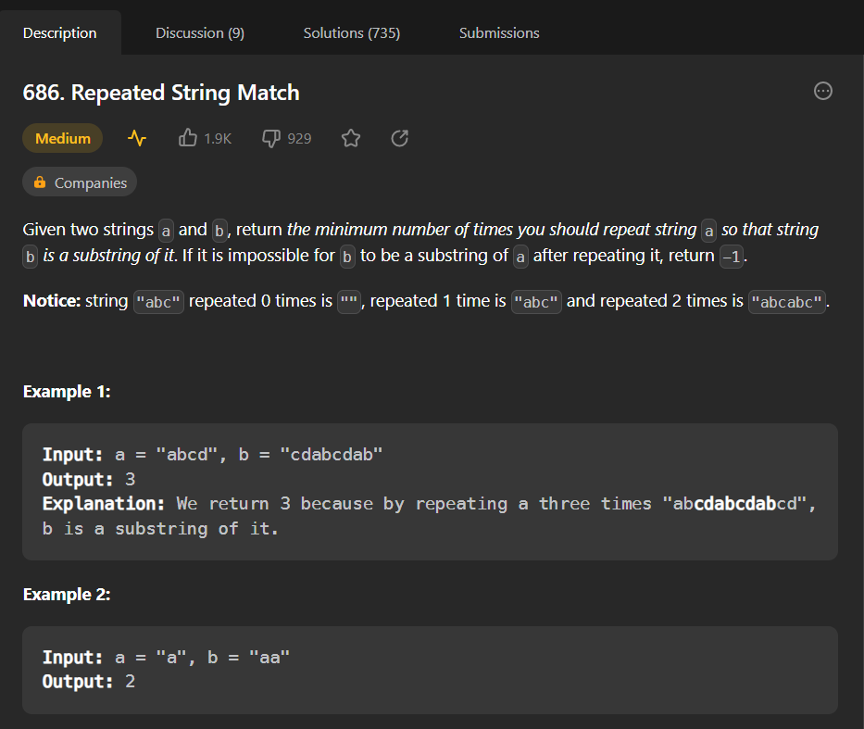

**Answer-**

